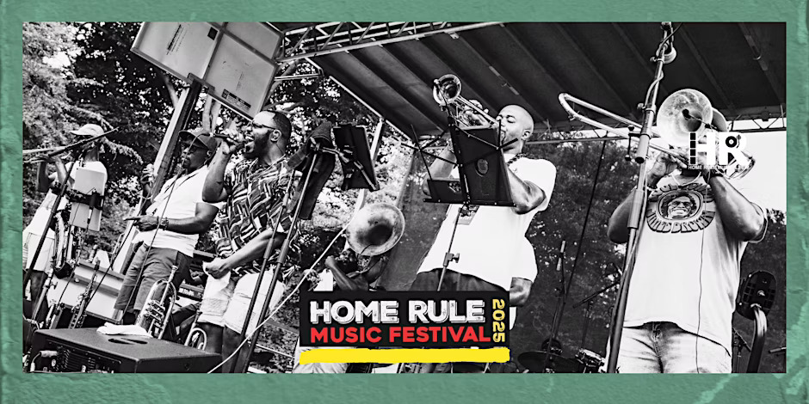

June 21, 12-9pm

**Home Rule Music Festival**

The [Home Rule Music Festival](https://www.homerulemusicfestival.com/)is a family-friendly event focused on the music and culture of Washington, DC. **Backyard Band** will headline the **2025 Home Rule Music Festival** — **presented by the Go-Go Museum and Cafe**! Bring your friends and family for a full day (1PM–9PM) of live music, community celebration, and cultural pride as the Home Rule Music Festival showcase the best of DC’s homegrown sound. Backyard Band will bring that unmistakable, raw go-go energy to the stage — an unmissable moment in DC music history.

**Full Festival Lineup Includes:**  
• Backyard Band • Plunky & Oneness of JuJu • Farafina Kan Ensemble  
• New Impressionz • Imani-Grace Cooper • Joantz Producer Showcase

**Festival Features:**  
• Record Fair • Local Food & Drink Vendors • Merch & Artisan Market  
• Live Mural Painting & Community Art • Sponsor Activations  
• VIP Experience with complimentary drinks, prime views & artist access

**Details:  
General admission for the festival on June 21 is free.** A limited number of VIP tickets are also available.  
Full schedule and lineup is available now at [homerulemusicfestival.com](http://homerulemusicfestival.com/).  
**Date:**June 21, 1 pm to 9 pm **Location:** The Great Lawn at The Parks at Walter Reed – Map 1301 Main Drive NW to walk or bike into the site.

**Road Closure: Main Drive will be closed on Saturday, June 21 from 10 am to 10 pm. Abrams Hall and SOME residents and visitors will only have vehicular access from 16th Street during this time. Festival attendees should park in the Marketplace Garage or walk/bike into the site. No parking will be allowed on Main Drive. See the map below.**

**Parking:**Parking is available at the Marketplace Garage near Whole Foods Market. Map 1155 Dahlia Street NW and follow the pink parking signs. The garage is accessible from entrances at Georgia Avenue and Dahlia Street NW, or Georgia Avenue and Elder Street NW. Park in the garage and walk **one block** down 12th Street to the Great Lawn (map 1301 Main Drive NW to walk there). ADA ramps are available on either side of the Great Lawn. See map below.