# [A close up of a logo AI-generated content may be incorrect.](https://www.campigliodolomiti.it/en/skiarea/inverno/skiarea-madonna-di-campiglio)

MARCH 14-21, 2026

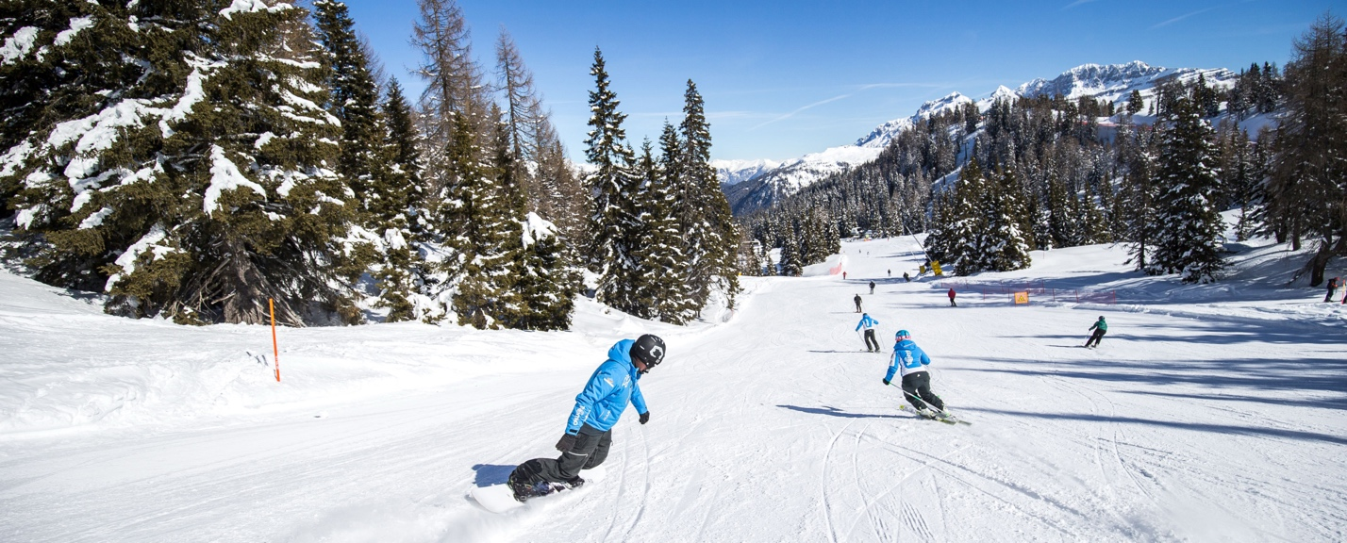

Top of Form

Ski the Dolomites at Trentino’s largest unified ski area:  [Skirama Dolomiti](https://www.skirama.it/en" \t "_blank) is a collection of eight resorts which includes Madonna di Campiglio.  The vast network of slopes, totaling 380km, is known for its diverse terrain, scenic beauty, and high-altitude ski opportunities.

Ski on 97 miles of interconnected runs across the three ski areas of Madonna di Campiglio, Pinzolo and Folgarida-Marilleva. Located at 1550m altitude in a natural conch, nestled between the Brenta Dolomites mountain range and the Adamello and Presanella glaciers, [Madonna di Campiglio](https://www.campigliodolomiti.it/en/skiarea/inverno/skiarea-madonna-di-campiglio) is one of the most important and well-known ski resorts in the Italian Alps.

**Our Base Package Includes (estimated pricing- $3,291double $3,901single)**

* Round trip air from Washington Dulles Airport to Venice via KLM/AF.
* Ground transportation from Venice airport to Madonna Di Campiglio (3-hour bus ride).
* Entrance into the BRSC Welcome Party, Après Ski Party, and Gala Dinner.
* Seven nights lodging at the Cristal Palace Hotel (4-star Hotel).
  + Buffet breakfast and dinner daily at your hotel.
  + Access to the wellness center, Turkish bath, fitness center, sauna, indoor pool with counter current system, whirlpool and spa (spa treatments are extra).
  + Free shuttle bus services to/from the Groste/Pradalago Fortina ski area (less than half a mile),

With the most spectacular view of Madonna di Campiglio, the [Hotel Cristal Palace](mailto:https://www.campigliocristalpalace.com/en/hotel/) stands dominant over the entire valley, which is just waiting to be admired. Behind the luxuriant woods of the Adamello Brenta Natural Park and in front of you the majesty of the mountains, breathtaking views, adrenaline-pumping adventures, ancient traditions, fashionable shopping and lively nightlife await.

At the Cristal Palace we guarantee thrills for all tastes. Our strength is the quiet location: away from the hustle and bustle but a short distance from the centre; convenient for reaching all services, but at the same time immersed in total relaxation and beauty. To relieve you of all worries, an efficient shuttle bus service is at your disposal to reach the centre and the ski slopes… we'll take care of everything!

*Cristal Palace Hotel Double Rooms*

Room and hotel amenities include:

* Safes, desks, and complimentary WiFi
* Shower/tub combinations and complimentary toiletries
* Buffet breakfast and dinner served daily
* Restaurant, bar and lounge
* Pamper yourself with a visit to the spa, which offers massages, body treatments, and facials.  A spa tub, Turkish bath, and a sauna offer a relaxing way to wind down after a day on the slopes.
* **BRSC Eurofest Features:** The trip includes several events as a feature of being the Blue Ridge Ski Council's annual Eurofest trip including:
* Welcome party
* Après ski party
* Gala farewell dinner

**Epic Pass Holders**receive seven consecutive days of skiing and riding at Skirama Dolomiti ski resorts (includes Madonna), as is explained on the [Epic Pass website](https://www.epicpass.com/regions/europe/italy/skirama-dolomiti.aspx).  Instructions for Epic Pass holders are presented on the [Skirama Dolomiti website](https://www.skirama.it/en/epic-pass-holders" \t "_blank).  Only the "full" Epic Pass is honored.  Epic Day Passes and Military Epic Passes do not provide access to Madonna.

**Resort Lift Tickets:** Skiers without an Epic Pass will be able to purchase lift tickets from Ski.com around October 2025. Their lift ticket prices are quite reasonable:

**Air Travel**: Important- As you know air travel can always be delayed. All trip participants are booked on the group flight with Ski com to fly out of Dulles International airport on the evening of Friday, March 13th around 630pm and will return to Dulles on the morning of March 22nd, unless staying on the post trip to Venice. **You cannot book your own international flights on this ski trip.** We suggest to all out of towners to book a flight into Dulles to land at least 5- hours prior to our departure time to give you time to relax and to assure you do not miss our international flight. On the return, please book a flight at least 3 hours after our scheduled arrival time estimated on March 21st at 535pm on to ensure you do not miss your flight home. (Please note flights are subject to change this far out): **NOTE:** You are allowed to carry 1 - and 1 suitcase in your free baggage allowance. KLM/Air France charge for ski/snowboard equipment please refer to their website for the pricing of ski/snowboard equipment.

*Late signups will be booked on* ***Swiss air*** *RT from Dulles and stay at the Savoia Palace Hotel also a 4-star hotel in the center of Madonna*.

Top of Form

**Venice Post Trip Option - $855 Double/ $1,304 Single 3**-Night -Skiing Extension Returning to the US on March 24, 2026

Three nights (Sat- Mon) in [The Hotel Anthony](https://www.sogedinhotels.it/en/antony-hotel-venice-airport/index), a 4-star hotel located between Mestre and Venice in the town of Campalto. It was renovated in 2018 and overlooks the Venetian lagoon, offering a beautiful and unusual view of Venice from the upper floors. It is located on the route between the international airport "Marco Polo" (3km) and the historic city center of the island (10 minutes away), a few metres from public transport stops, allowing you to quickly get to Venice, the airport and the tourist port. A private shuttle service is also available for guests. Daily breakfast is included. Features include: Three nights’ stay with breakfast included.

Saturday, Mar 21 – Ground transport from Madonna to the airport to say goodbye to our Ski-Only group returning to DC, then on to the Hotel Anthony. Explore Venice (on your own). Consider a ride through the canals on a Gondola.

* Sunday, Mar 22 – Round-trip water taxi transfer from our hotel to St. Mark Square for a guided half-day city tour.
* Monday, Mar 23 – Explore Venice (on your own).  Consider a day trip by train to Bologna or another nearby town.
* Tuesday, Mar 24 – Ground transport from our hotel to the Venice airport.

**Ski club Membership Requirement:**   You must be a ski club member of Black Ski or another NBS club or /BRSC club.

P**lease note this updated Payment Schedule: May 25,2025- $850, July 1, 2025 -$850,**

**Sept 1st -$1,000.00, Nov 1st - $1,000.00, Nov 15th final balance due. \*There is a charge of $30.00 on all bounced checks, there is a late payment fee of $25.00 on all payments made 5 business days after the payment due date. Mail payments to Ski.com 1512 Grand Avenue Suite 212, Glenwood Springs Colorado, 81601 account #15170-600015854-J7**

**Trip Insurance:**Trip insurance Is highly recommended for all trip participants. You may purchase your insurance coverage from Ski.com via your registration booking number.

Please note there are no trip refunds after July 1, 2025, but if you find a suitable replacement for your spot we will do our best to work with you. **Ski club Membership Requirement:**   Your Black ski club membership must be current when signing up for the trip and throughout the duration of the trip.  As a "BRSC trip," the trip is automatically "sanctioned" through the Blue Ridge Ski Council.  Current members of other NBS clubs or BRSC member ski clubs may register for the trip.  Please have your membership chairperson send our trip director’s verification that club membership is active through the trip dates.

Tanya Jones Lori Sealy

[Tanya.bsi@yahoo.com](mailto:tanya.bsi@yahoo.com) [seesealy@yahoo.com](mailto:seesealy@yahoo.com)  
240-460-0471 (h) 240-508-6141 (c)

Bottom of Form